The 36th National Conference on Combustion and Energy
Author¹, Author^{2,3}*
¹Author #1 Affiliation
²Author #2 Affiliation
³Author #2 Affiliation
*Corresponding Author, Email: xxx@nycu.edu.tw
NSTC Project No: NSTC XXX- XXXX-X-XXX-XXX

The 36th National Conference on Combustion and Energy will be held on April 25, 2026, at the Guangfu Campus of National Yang Ming Chiao Tung University, Hsinchu City. All submitted manuscripts must conform to the formatting requirements specified in the conference submission template. To facilitate authors in preparing manuscripts that comply with the conference format, a WORD template is provided for download and use. The extended abstract must not exceed two pages and should briefly address the following four sections: research motivation, research methodology, results, and conclusions. Authors must strictly adhere to the formatting rules defined in the template and convert the document to PDF format prior to submission (please do not edit page numbers in the PDF file). The PDF file should then be uploaded to the official conference website at https://ncce2026.conf.tw to complete the submission process. The submitted file size must not exceed 5 MB. 【Font Settings】Only Times New Roman and symbol fonts are permitted. The paper title should be set in bold, 14 pt. Author names (bold) and affiliations should be set in 12 pt, while all other content should be set in 11 pt. Each paragraph should begin with an indentation equivalent to 0.8 cm. 【Margin Settings】The manuscript page size must be A4 (21 cm × 29.7 cm), with margins set as follows: top 3 cm, bottom 3 cm, left 2 cm, and right 2 cm. These margin settings must not be altered under any circumstances.
【Figures and Tables】Authors may place all figures and tables collectively at the end of the manuscript (as shown in the template) or embed them within the text; both arrangements are acceptable. Figure and table captions should be set in 11 pt. Caption alignment may be centered or left-justified depending on the width of the figure or table. 【Equations】Equations must be centered and accompanied by equation numbers. References should strictly follow the formatting requirements specified in the conference template; examples are provided below for reference.

Keywords: Please provide at most 5 keywords and separate them with semicolon (;).

Acknowledgments
This work was supported by the National Science and Technology Council, Taiwan, under contract NSTC XXX-XXXX-X-XXX-XXX.

References
- Yan, H. S., “Creative Design of Mechanical Devices”, Springer, Singapore, 1998.
- Iijima, S., “Helical Microtubules of Graphitic Carbon”, Nature 1991, 354, 56-58.
- Vechet, S., Krejsa, J., Chen, K. S., “AGVs Mission Control Support in Smart Factories by Decision Networks”, Proceedings of the 19th International Conference on Mechatronics - Mechatronika (ME 2020), Prague, Czech Republic (2020).

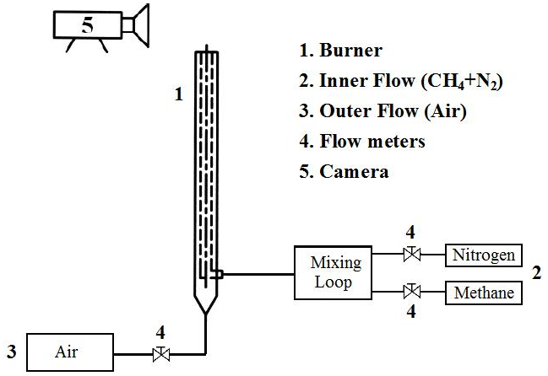

Fig. 1. Schematic of jet flow system.

